## PCB Design

After finalizing the simulation result and component selection, we moved into the PCB design. For this purpose, we have used Altium Designer software.

Previously, we had drawn the schematic library and footprints of the selected components for Simulation Report. Since the snubber and transformer design were not finalized, they were missing in the simulation report. The circuit schematic of the updated final design is given below.

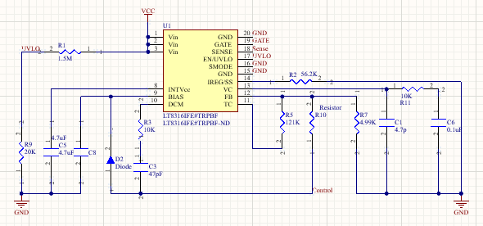

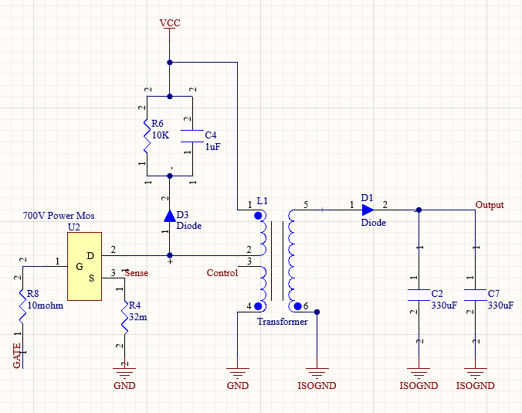

In the first picture, the controller and feedback part of the controller can be seen. In the second picture, the switching MOSFET, snubber unit (R6, C4, D3), transformer, output capacitor and diode can be seen. The second winding on the primary side represents the feedback of the controller. We have ensured the isolation with the ISOGND ground connection in the secondary side. According to this schematic, the PCB design is composed of 11 resistors, 6 capacitors, 3 diodes, 1 switching MOSFET, 1 transformer and 1 IC controller. In order to decrease the of the PCB, we have selected the components as small as possible.

After components selection, we have drawn the footprints of the component. In here, we have used the 3D bodies for the components except for the transformer. Since it is designed as custom, there is an extruded 3D body for the transformer according to its dimensions.

The overall view of the PCB is given below.

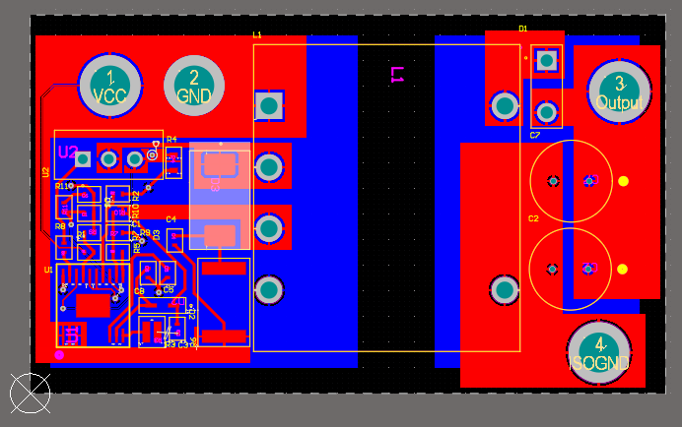

Figure 1. Overall PCB Design

We have used THD packaged component for diode, transformer, MOSFET, and output capacitors. Also, we have full fill the bottom part with ground and isolated ground polygons. Thus, we did not prefer place any components on the bottom part although we desire a compact design. The reason is avoiding from electromagnetic interference on the device by dividing the ground polygons.

For the input and output voltages, and ground connections, we have transmitted the power via polygons instead of thin tracks in order to avoid any damage of the high power density. Also, we have used polygons whereas the circuit geometry allows the range areas. The other tracks are made with 0.4mm width. The 2D top and bottom view of the PCB is given below.

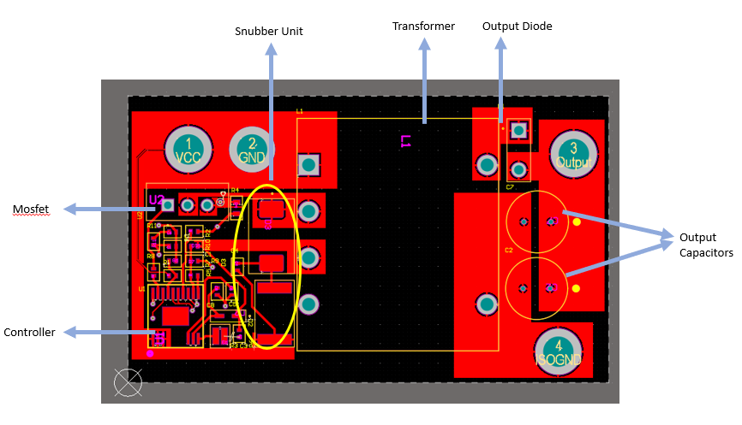

Figure 2. Top view of the PCB

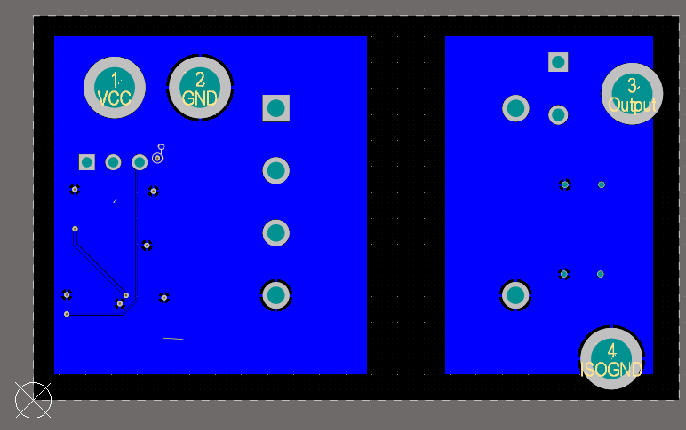

Figure 3. Bottom view of the PCB

In order to prevent violating the isolation, we have a gap between grounding of the primary and secondary side.

The size of the PCB card is 37mm*62mm in final. The height of the circuit depends on the transformer height, so it is 30mm. The leads of the THD components can be trimmed while the manufacturing. The 3D views are given in below.

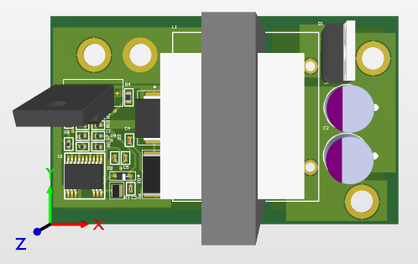

Figure 4. Top view of the PCB

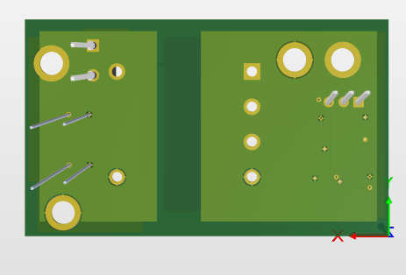

Figure 5. Bottom view of the PCB

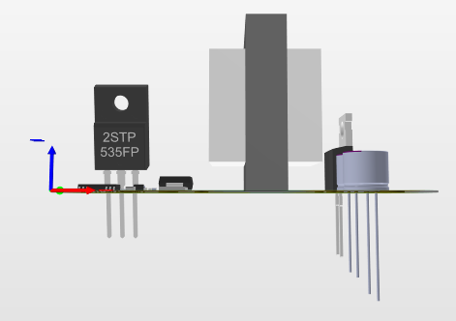

Figure 6. Side view of the PCB